Constraints are rules and restrictions applied on a column or a table such that unwanted data can't be inserted into tables. Constraints can be specified when the table is created (inside the CREATE TABLE statement) or after the table is created (inside the ALTER TABLE statement). This ensures the accuracy and reliability of the data in the database.

Constraints can be classified into the following two types.

**Column Types Constraints: -** Definitions of these types of constraints is given when the table is created.

**Table Types Constraints**:-Definitions of these types of constraints is given after the creation of the table using the Alter Command.

SQL Server contains the following 6 types of constraints:

* Default Constraint
* Check Constraint
* Unique Constraint
* Not Null Constraint
* Primary Constraint
* Foreign Constraint

**Default Constraint**  
  
Specifies a default value for when a value is not specified for this column. If in an insertion query any value is not specified for this column then the default value will be inserted into the column.

**Column Level  
  
Syntax**

1. **Create** **Table** Table_Name
2. (
3. Column_Name DataType **Constraint** Constraint_Name **Default**(Value),
4. )

**Table Level  
  
Syntax**

1. **Alter** **Table** Tabel_Name
2. **Add** **Constraint** Constraint_Name **Default**(Value) **for**[Column_Name]

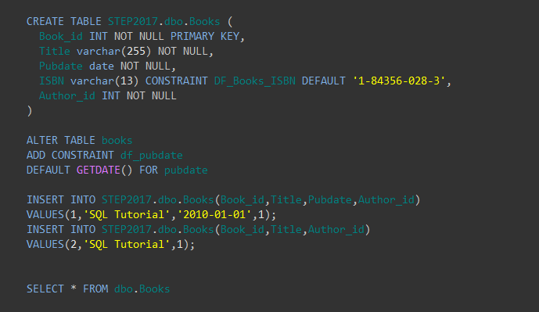

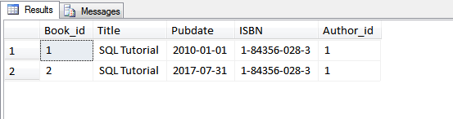

**Check Constraint**  
  
A Check constraint checks for a specific condition before inserting data into a table. If the data passes all the Check constraints then the data will be inserted into the table otherwise the data for insertion will be discarded. The CHECK constraint ensures that all values in a column satisfies certain conditions.

**Column Level  
Syntax**

1. **Create** **Table** Table_Name
2. (
3. Column_Name Datatype **Constraint** Constraint_Name **Check**(Condition)
4. )

**Table Level  
  
Syntax**

1. **Alter** **Table** Table_Name
2. **Add** **Constraint** Constraint_Name **Check**(Condition)

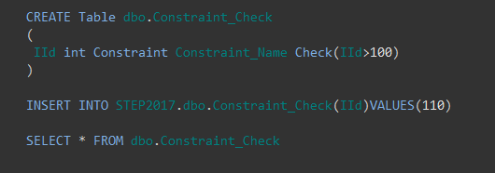





The INSERT statement conflicted with the CHECK constraint "Constraint_Name". The conflict occurred in database "STEP2017", table "dbo.Constraint_Check", column 'IId'.

**Unique Constraint**  
  
It ensures that each row for a column must have a unique value. It is like a Primary key but it can accept only one null value. In a table one or more column can contain a Unique Constraint.  
  
**Column Level  
  
Syntax**

1. **Create** **Table** Table_Name
2. (
3. Column_Name Datatype **Constraint** Constraint_Name **Unique**
4. )

**Table Level  
  
Syntax**

1. **Alter** Table_Name
2. **Add** **Constraint** Constraint_Name **Unique**(Column_Name)

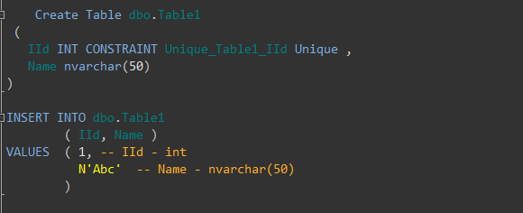

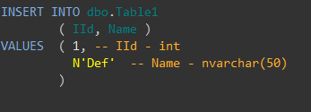

Violation of UNIQUE KEY constraint 'Unique_Table1_IId'. Cannot insert duplicate key in object 'dbo.Table1'. The duplicate key value is (1).

**Not Null Constraint**  
  
A Not null constraint restrict the insertion of null values into a column.

**Column Level  
  
Syntax**

1. **CREATE** **TABLE** Table_Name
2. (
3. Column_Name Datatype **CONSTRAINT** Constraint_Name NOT NULL,
4. );

**Table Level  
  
Syntax**

1. **ALTER** **TABLE** Table_Name
2. **ALTER** **COLUMN** Column_Name Datatype NOT NULL

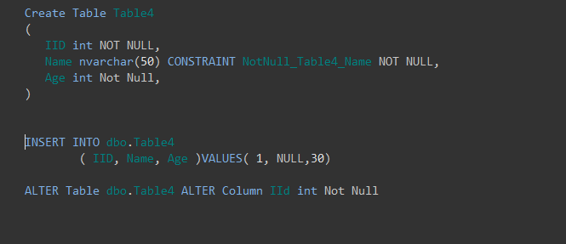

Cannot insert the value NULL into column 'Name', table 'STEP2017.dbo.Table4'; column does not allow nulls. INSERT fails.

The statement has been terminated.

**Primary Key Constraint**  
  
A primary key uniquely identifies each row in a table. It cannot accept null and duplicate data. One or more of the columns of a table can contain a Primary key.

**Column Level**  
  
**Syntax**

1. **Create** **Table** Table_Name
2. (
3. Column_Name Datatype **Constraint** Constraint_Name **Primary** **Key**,
4. )

**Table Level  
  
Syntax**

1. **Alter** **Table** Table_Name
2. **Add** **constraint** Constraint_Name **Primary** **Key**(Column_Name)

**Foreign Key Constraint**  
  
A Foreign Key is a field in a database table that is a Primary key in another table. A Foreign key creates a relation between two tables. The first table contains a primary key and the second table contains a foreign key.

**Column Level  
  
Syntax**

1. **Create** **Table** Table_Name
2. (
3. Column_Name Datatype **Constraint** Constraint_Name **References** Reference_Table_Name(Reference_Column_Name)
4. )

**Table Level  
  
Syntax**

1. **ALTER** **TABLE** Table_Name
2. **ADD** **CONSTRAINT** Constraint_Name **FOREIGN** **KEY**(Column_Name)
3. **REFERENCES** Reference_Table (Column_Name)

**Drop a Constraint**

1. **Alter table** Table_Name
2. **Drop Constraint** Constraint_Name